Quick Phone Guide

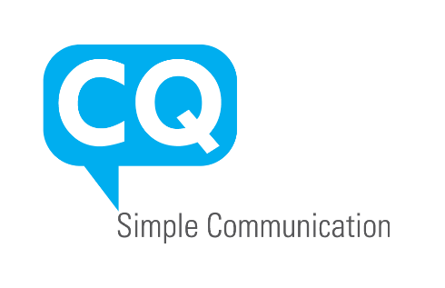

Setting Up Voicemail and Greetings:
Within your voicemail, dial 0 to go to the Mailbox Options Section.
From there you can dial one of the Following:
1 Record Unavailable Message
2 Record Busy Message
3 Record your Name
4 Manage your Temporary Greeting
-When you record your temporary greeting it will become the dominate message played when anyone calls your phone. When you come back, from vacation for example, you must delete that message for the phone to revert back to using your original messages.
5 Change Password
*Note* Once you dial one of these options the phone system will talk you through each process of recording, reviewing, and accepting.
Popular Feature Codes
Call Directly to a Colleague’s Voicemail
Dial *xxx, where xxx is the extension of the voicemail you wish to leave a message in. Avoids having their phone ring.
Intercom
Dial *80xxx, where xxx is the extension you wish to intercom. – For Single Extension intercom
Dial xxx, where xxx is a page group setup by your administrator. – For Paging of multiple extensions simultaneously
On-Demand Recoding
Dial *1, while engaging in a conversation you wish to record. Pressing *1 again will stop the recording.
Blacklist a Caller
Dial *32 to blacklist the last caller on your extension
Do Not Disturb Toggle
Dial *76 to toggle the Do Not Disturb feature on your phone.

Extension List and Recordings
101 –
102 –
103 –
104 –
105 –
106 –
107 –
108 –
109 –
110 –
111 –
*292 – Main Greeting
*293 – Service Times
Line Keys Speakerphone Multipurpose Keys
Menu
Voicemail
Mute
Headset
Hang-up
Redial
CQ600 Key Guide
Programmable Keys – Press and Hold to Check/Change
Red – Extension in Use, Green – Extension not in Use.

Call Flow (Example):

M-F (9am-5pm) Rings Office(101) and Becca(103) for ~3 rings Auto-Attendant
All other times Auto-Attendant

Auto-Attendant Setup (Example):
To change the auto-attendant greeting dial *292 from any phone, the message will play back and it will give directions on recording a new message. When finished recording your message press # to save it
If you decide to change where a call is routed when the caller enters a number that will require both a change in your greeting and programming within the platform

Press 1
Press 2
Press 3
Press 4
Press 5
Press 6
Press 7 Service Times and Address (To change this announcement dial *293 from any phone, the message will play back and it will give directions on recording a new message. When finished recording your message press # to save it)

